**A94-ME-Uruk-Inanna-Ishtar-Figurine-Limestone-2100 BCE**

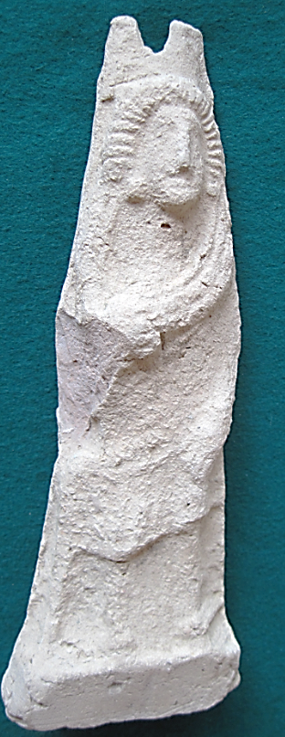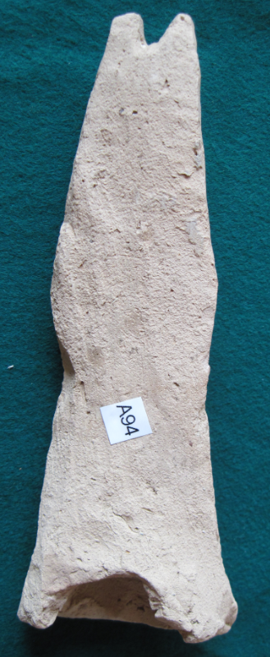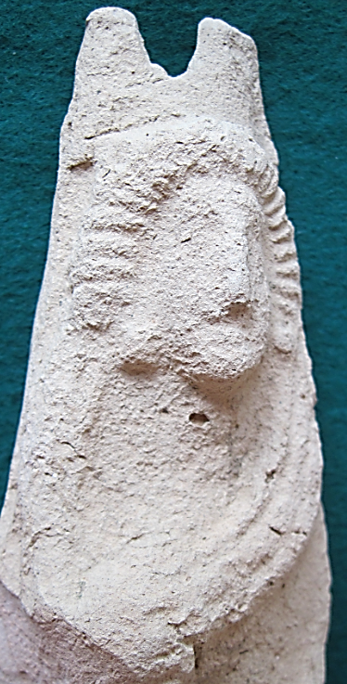

**Figs. 1-3**. Uruk, Inanna-Ishtar Limestone Figurine, ca 2100 BCE **Case no.: 4**

**Accession Number: A94**

**Formal Label**: Uruk, Inanna-Ishtar Limestone Figurine, ca 2100 BCE

**Display Description:**

Uruk, Inanna-Ishtar Limestone Figurine, ca 2100 BCE, wearing a 28-point radiating tiara that indicates her female Moon-menstrual period of 28-days, which she derived from being the daughter of the Moon-god Nanna-Sin (also Enki, or Anu, and his wife Ningal) (DDD 1999:452). This is one aspect of Innanna-Ishtar as Mother of the living. Another aster is when she is depicted as the wife of Dummuz/Tamuz (DDD 1999: 452). Her tiara is surmounted by a turreted headdress of Uruk’s many Turret Towers, ca 2100 BCE. A flounced skirt proclaims her divinity.

Inanna-Ishtar was pivotal for Uruk’s history: she absconded with the *MEH* (the foundation decrees of Sumerian civic life) from the Eridu to Uruk, signifying a transference of power to her new city. Once her father found the *MEH* were transferred he sought to recover them but in vain. Inanna had established Uruk as the seat of power. Old Eridu had been the center of rural life but now Uruk was the embodiment of the new way of life of the city. Consequently, Eridu declined as Uruk rose In Uruk Inanna-Ishtar had her Eananna Ziggurat built, complete with a turreted wall which was considered her literal dwelling place ca 2100 BCE. Inanna-Ishtar continued to be a popular deity until women’s rights deteriorated and the goddess’ power declined. Finally, the Eanna district was walled off to restrict access to Inanna-Ishtar to a male priestly class (Kramer 1963).

**LC Classification**: DS62.23.U78

**Date or Time Horizon**: ca 2100 BCE

**Geographical Area:** Uruk

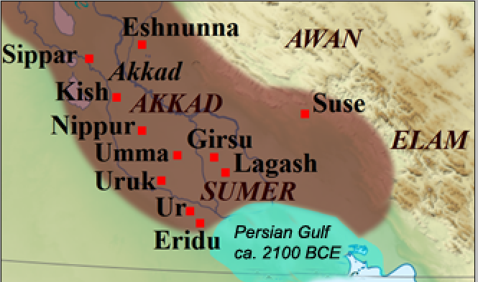

**Fig. 4.** Map of Sumer and Akkad, ca 2100 BCE

**GPS coordinates:** Uruk, [31°19′27″N 45°38′14″E](https://tools.wmflabs.org/geohack/geohack.php?pagename=Uruk&params=31_19_27_N_45_38_14_E_type:landmark)

**Cultural Affiliation:** Sumerian

**Medium: limestone**

**Dimensions:** H180.23 mm, 7.09 in

**Weight:** 199 g, 7 oz

**Condition:** original

**Provenanc**e: similar to “Standing Ishtar, MacKenzie Art Gallery, University of Regina Collection.”

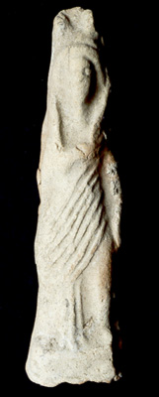

Fig. 5. Standing Ishtar, 14.60 x 3.90 x 2.30 cm, University of Regina Collection, gift of Mr. Norman MacKenzie. 1983-031-018.

Discussion:

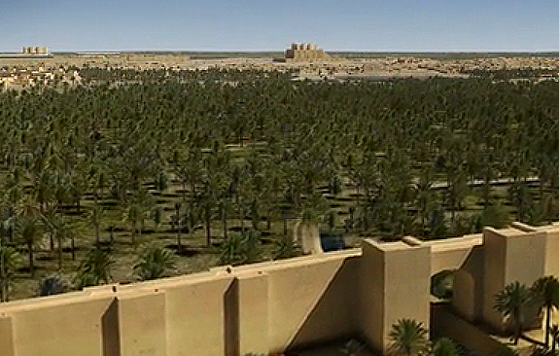

Fig. 6. Reconstruction of Uruk’s City Turret Towers ca 2100 BCE from “URUK – 5000 Years of the Megacity”. Turrets symbolized in the headdress of the limestone figurine of Inanna-Ishtar are featured in main city turrets, foreground right above, Eshgal and City Center (Resch Zentrum), background left, and Eanna (=nanna-Ishtar) Inanna-Ishtar) Ziggurat, right background. 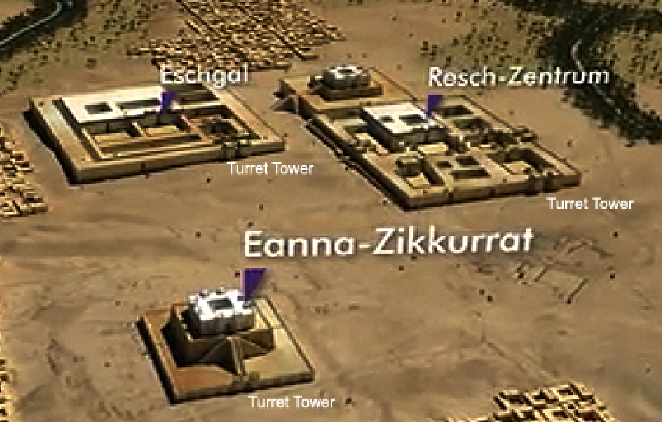

Fig. 7. This reconstruction of the temples of Uruk (Eanna-Zikkurat=Inanna-Ishtar Ziggurat) , Eschgal and Resch-Zentrum (City Cernter) in the [Deutsches Zentrum für Luft- und Raumfahrt e.V. (DLR)](http://www.dlr.de/eoc/de/desktopdefault.aspx/tabid-5245/mailcontact-9039/) shown at the Pergamon Museum, a joint project of the Staatliche Museen zu Berlin's Vorderasiatisches Museum (Museum of the Ancient Near East), the Curt-Engelhorn-Stiftung für die Reiss-Engelhorn-Museen in Mannheim, the Orient Department of the German Archaeological Institute, and the German Oriental Society. From URUK: Reconstruction Based on Satellite Data, October 21, 2013.

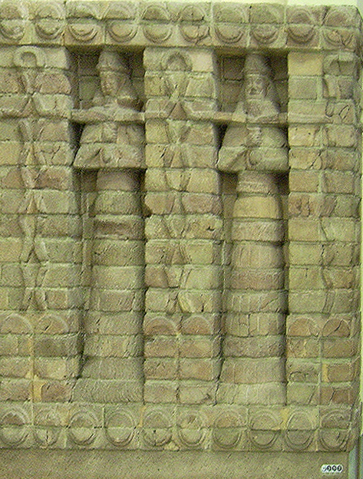

Fig. 8. Part of the molded baked-brick bas-relief of the temple of the Kassite king, Karaindaš 1410 BCE, from [Uruk](https://en.wikipedia.org/wiki/Uruk" \o "Uruk) in the Vorderasiatisches Museum of Berlin.jpg. Height 205 cm This temple was constructed from five hundred pre-formed baked bricks, which were set in recessed [socles](https://en.wikipedia.org/wiki/Socle_(architecture)" \o "Socle (architecture)), with alternating male and female deities holding water jugs. The bearded males wear horned flat caps and double streams of water flow symmetrically to frame the niches. Here the male king isbeginning to usurp the rôle of Inanna-Ishtar as both the receiver of the Dead and the Father of the Living (DDD 1999: 454). In the façade above water of the living world is filling vases with water spewed from vertical columns of water glyphs ., while below are the waters of the netherworld of the Dead with a separate bounded, encircled-glyph for water . The Eanna district was now walled off to restrict access to Inanna-Ishtar to a male priestly class (Kramer 1963).

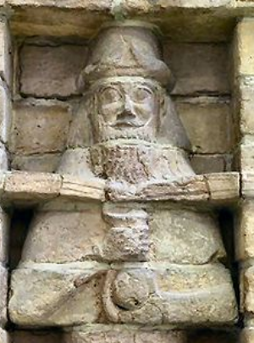 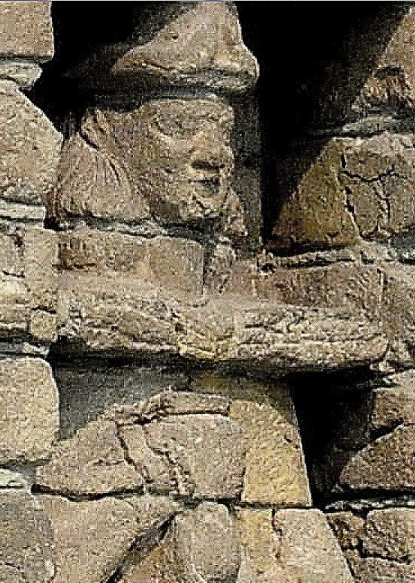

Figs. 9, 10. Detail of Uruk temple 1410 BCE of Kara-indasch: left, Kassite king Karaindaš, and, right, Inanna-Ishtar. From molded baked-brick bas-reliefs, in the Vorderasiatisches Museum of Berlin.jpg. The king’s beard is sculpted as flowing water flowing with water from the fountain plinth into the vase which he holds from below. This implies that he is also the source of water, i.e., Life. Inanna-Ishtar grasps the vase from the side as the water fills it solely from the fountain plinth above. This implies that she relies on an external source of water, i.e., Life. Note that both wear the horned-headdress indicating masculine divinity. By 1410 BCE Inanna-Ishtar no longer wears the turreted headdress of Uruk, and is therefore, no longer its chief divinity.

**References:**

Black, Jeremy; and Anthony Green. 1992. *Gods, Demons and Symbols of Ancient Mesopotamia: An Illustrated Dictionary*. London: The British Museum Press.

Collins, Paul. 1994. "The Sumerian Goddess Inanna (3400-2200 BC)", *Papers of from the Institute of Archaeology*, 5. London: UCL.

DDD. 1999. *Dictionary of Deities and Demons in the Bible. DDD*. Ed Karel van der Toorn, Bob Becking, Peter W. Van der Horst. Second ed, Boston: Brill.

Guirand, Felix.1968. "Assyro-Babylonian Mythology," *New Larousse Encyclopedia of Mythology*. Translated by Ames Aldington. London, England: Hamlyn, pp. 49–72.

Kramer, Samuel Noah. 1963. *The Sume*rians. Chicago: University of Chicago Press.

Parpola, Simo. 2004. "Assyrian Identity in Ancient Times and Today" <http://www.nineveh.com/parpola_eng.pdf>

Wilkinson, Philip (1998), *Illustrated Dictionary of Mythology*. New York: Dorling Kindersley.